**IBM Project Report**

**Gas Leakage Monitoring and Alerting System**

Team ID: PNT2022TMID49784

|  |  |  |  |
| --- | --- | --- | --- |
| **S.No** | **Contents** | **Topics** | **Page.no** |
| 1 | Chapter 1 | INTRODUCTION | 2 |
| 2 | Chapter 2 | LITERATURE SURVEY | 3 |
| 3 | Chapter 3 | DESIGN OF GAS ALERT SYSTEM | 10 |
| 4 | Chapter 4 | IMPLEMENTATION | 21 |
| 5 | Chapter 5 | RESULTS | 32 |
| 6 | Chapter 6 | CONCLUSION | 36 |
| 7 | References |  | 37 |

CHAPTER 1

**INTRODUCTION**

* 1. **OVERVIEW**

Here, Arduino UNO R3 is used as a microcontroller which controls all the setup in the board. By the using Arduino IDE dump the code to the microcontroller. MQ7 gas sensor is used to detect the Carbon monoxide in the environment, MQ135 sensor is used to detect Carbon di oxide and H2S in the air. In the 1st case, By the use of Rf transmitter and receiver imported wireless connection for sending and receiving the data which was sensed by the gas sensors. After receiving the data, the Vibration motor vibrate for the sake of alert the worker. In the 2nd case, when sensor sense the toxic gas, it will send the message to the authority by the ESP8266.

* 1. **NEED OF THIS PROJECT**

This proposed model will immediately alert the worker by vibration. Worker suddenly intimated and go away from the toxic environment. From the ALERT message, the authority sends the rescue team to the hazardous area.

* 1. **OBJECTIVE**

Detecting toxic gases such as CO, H2S, CO2 in an industrial environment and alert the workers in the right time and also send the warning message to authority.

**1.4 PROBLEM STATEMENT**

In the system, it could do two processes simultaneously for to alert the worker by the Vibration motor and send the message to the authority at the same time. So, to save the valuable worker’s lives from the cause of dangerous gas and send the rescue team to that spot to rectify the accident.

**CHAPTER 2**

**LITERATURE SURVEY**

Mobasshir Mahbub, 2019, [11] “Toxic and hazardous gas detection, measurement and monitoring system for safety assurance in home and industrial application of wireless sensor node”. In this paper they get the two outcomes. One is sending message to the authority using GSM module SIM900 is used to send SMS and other is displayed the measured in the LCD display. Used components are Arduino UNO R3, MQ2 gas sensor nRF24L01 plus wireless Transceiver module. nRF24L01 is a receiver chip which is configured and operated through Serial Peripheral Interface (SPI). MQ2 gas sensor is designed to detect or measure the following gases: LPG, Alcohol, Propane, Hydrogen, CO and Methane. Its operating voltage is from 0-5V, the analog signal from the MQ2 Gas sensor is further fed into LM393 High precision Comparator for to soldered on the bottom and then little potentiometer to increase sensitivity of the sensor. With the help of Formula find the %of gases in the environment. Implement this model in the Breadboard. Using SIM900 is used to send SMS finally display the measured output in LCD display.

Karthika S, Vanitha U, Rejina Parvin, Supraja Arasu T, Sampritha R V, Srinithi K, 2019 [9] “Toxic gas detection using Low power controller with Alert system”**.** This paper is based on a system, which is used to detect various hazardous gases with the help of Arduino microcontroller. The toxic gases like butane, Carbon monoxide and methane in environment are sensed and displayed on the LCD screen. The concentration of the gasses will be shown in the form of percentage by LCD display. They used ATmega328 as a microcontroller and gas sensing sensors are MQ2, MQ4 and MQ9. And also show the measured data in serial monitoring window in IDE.

Katole K.R, Tamgade S.N, Morey P.R, 2019 [10] “Design and Implementation of Hazardous gas leakage detection system for industrial area”. On-site toxic gas detection is one of the most dangerous issues in the industry. This paper shows how to detect the leakage of toxic gas and take preventive measures to prevent the leakage. The input is processed and the output is sent to the warning system, exhaust fan, and solenoid valve. The input sensor used to detect gas leaks is the MQ-7 gas sensor. The analog input from the sensor is provided to the system as a digital input via DAQ. It is then compared to the state of the LabVIEW environment to get the appropriate output. This control signal is sent via DAQ to the output device that controls the gas leak. The people who are all surrounding the industry are saved.

Mohammad Monirujjaman Khan, 2020, [12] “Sensor-based gas leakage detector system”. This paper aims to measure and analyse the real time levels of toxic gases. In order to ensure safety of the workers working under such severe conditions. This project attempts to device an IOT technology that shall detect the humidity, temperature levels and mixture of gases, sensing each type of gas to measure its level while keeping track of the real-time dynamic changes in the above factors. The gas sensors MQ2 and MQ6 are interfaced Arduino UNO to detect toxic gas values present in the sewage system. If levels exceed beyond threshold, it shall send an alert on the connected mobile devices of the authorized people who are remotely located in the job. If any blockage is encountered, it can be monitored with the help of live video streaming. By using the ESP8266 Wi-Fi module to send the measured values to the authority. Through the ESP8266 the measured data are stored in the Thing speak.

Bichinapally Sruthi, Sreenivasulu E, 2018 [3] “Alerting and detection of toxic gases in industries using the internet of things”. The project aims to provide an intelligent solution for monitoring toxic sewage gas, working on a real-time sewage level detection and monitoring system. When a certain threshold is exceeded, an alert is sent to the observer who is examining the condition from a remote location. The information is then passed along with various gas ppm values ​​that indicate whether it is safe for the worker to clean or work in the environment. Integrate remotely located IoT monitoring devices with IoT platforms to create the proposed system. This requires calibration of gas sensors for industrial purposes and determination of the correct thresholds for sewage treatment plants and facilities. The hardware is designed to be safe by sending pre-alerts to workers as the concentration of harmful gaseous components increases over time. Various types of sensors are used to monitor parameters that exist in the industry such as gas and temperature. When the threshold falls below the detection value, the system sends an SMS, analyses the concentration of various toxic gases and raises an alarm by displaying the results, alerting workers for real-time monitoring. This helps protect against dangerous illnesses and has a social purpose. In the proposed system, an example of the sensor value was recorded and displayed in the analysis tool Thing Speak. The carbon monoxide sensor and the methane sensor showed high measurements of 2.3 and 2.3, respectively. At 60ppm, this is above the threshold and the GSM module was used to send an alert to the mobile number entered in the code.

Jianyun Ni, Zohao Li, Shuzhi xie, chaojia, 2019 [7] “Detection of hazardous gas using wearable wireless sensor for industrial applications”. Air pollution is a mixture of solid particles and gases in the air. Car emissions, chemicals from factories, dust, pollen and mould spores may be suspended as particles. Effect of air pollution has many bad things and the others may cause problems to human health, for instance, asthma, cough, and lung disorders. In addition, the pollutant can cause global warning, acid rain, and disturbing plant growth. Basically, a human cannot determine whether the air is good or not. Hence, it is necessary to have a tool that can measure the air quality. This research is purposed to design an air quality monitoring system by utilizing esp8266 module. As the result, users can monitor the air quality using smartphone connected through ESP8266 Wi-Fi. Therefore, the air condition can be monitored every time. Currently, there is so much air pollution cases that actually can be changed. In other words, a contribution as part of the solution instead part of the pollution will give the solution to the problem.

“Toxic Environment Monitoring using sensors based on IoT”. This paper is an excellent result for observing the toxic gases in hazardous environment for safety applications and generate the information visible anyplace within the world. IoT systems have applications across industries through their distinctive flexibility and capacity to be appropriate in any atmosphere. One of important component in IoT is sensors. Use Rf modules, establish wireless connection and upload the measured data to the cloud via ESP8266 Wi-Fi module through internet. Here Arduino UNO as a microcontroller and MQ7 sensor is used to detect CO, Hydrogen sensor is for Hydrogen gas, MQ2 is for detect flammable gas.

Chalasani Srinivas and Mohan Kumar, 2018 [4] “Toxic gas detection and monitoring utilizing IoT”. Harmful gas leakage accidents are the main reason for workers death in industries which work mainly using chemicals. Gas leakage can be easily detected and controlled by using latest trends in information technology by applying internet of things. This project intended to avoid industrial accidents and to monitor harmful gases and to intimate alert message to safety control board of industry using Arduino Uno R3 and internet of things. Ardunio Uno R3 board is used as central microcontroller which is connected with sensor. Such as temperature, gas sensor, alcohol sensor which can continuously monitor respective environmental parameters. Hence this device may be used as multi gases detection apparatus more over the rate of response is high. An alarm is produced instantly if the level of the gases goes above the normal level means indication through the internet specific receiver section. Data received by sensor is stored in internet which can be used for further processing and it can be analysed for improving safety regulations. This model can be future extended for providing better living environment for people in and around industries with a pollution-controlled environment.

**Table 2.1 Literature Survey**

|  |  |  |  |  |  |
| --- | --- | --- | --- | --- | --- |
| TITTLE | AUTHOR | YEAR | METHODOLOGY | FINDINGS | PROS / CONS |
| Gas leakage detection based on IOT. | Suma, V., Ramya R. Shekar, and Kumar A. Akshay | 2019 | ARM Cortex-M, MQ-2 gas sensor, LPG sensor | The main objective of the work is designing microcontroller based toxic gas detecting and alerting system. The hazardous gases like LPG and propane were sensed and displayed and notify each and every second in the LCD display. If these gases exceed the normal level then an alarm is generated immediately and also an alert message (Email) is sent to the authorized person through the INTERNET and used ARM development board. | Pros:  This results in a more efficient in operation because it is connected to a common web page specially built to notify or email the responsible authority automatically so reduces the stress of constant monitoring.  Cons:  cost is high,complex to design |
| IOT based industrial plant safety gas leakage detection system | Kodali, Ravi Kishore, R. N. V. Greeshma, Kusuma Priya Nimmanapalli, and Yatish Krishna Yogi Borra | 2018 | MQ-6 sensor is used for sensing LPG concentrations in air.MQ-4 sensor for Methane and MQ-135 sensor for Benzene. | This project proposes a leakage detector which sends the warning to the concerned people through SMS. This detector senses the presence of harmful gases particularly, LPG, Methane and Benzene. | Pros:  In this system architecture, multiple sensors are placed around the region of interest in the plant. An IFTTT based gas leakage detection system with an alerting message feature to the response team is presented. The Sensing System detects the leakage and Alerting system sends a warning message through IFTTT  Cons:  Network coverage |
| GSM based gas leakage detection system | Shrivastava, Ashish, Ratnesh Prabhaker, Rajeev Kumar, and Rahul Verma | 2013 | GSM , RF link ,Gas sensor MQ-6, stepper motor Driver IC (ULN2003A), Microcontroller (AT89C51). | The aim of this paper is to present such a design that can automatically detect and stop gas leakage in vulnerable premises. In particular gas sensor has been used which has high sensitivity for propane (C3H8 ) and butane (C4H10). Gas leakage system consists of GSM module, which warns by sending SMS | Pros:  The gas leakage system can react in time.  Cons:  The efficiency and memory of the microcontroller can be increased if Philips microcontroller is used in place of AT89C51. |
| Electronic design of liquefied petroleum gas leakage monitoring, alarm, and protection system based on discrete components | Attia, Hussain A., and Halah Y. Ali | 2016 | Liquefied Petroleum Gas, gas leakage, LPG detector, Operational amplifier, drive circuit, Buzzer, Valve. | This paper presents an alternative engineering solution of a simple system through a full electronic analog design based on discrete components. The proposed electronic system works on continuous detecting LPG gas leakage level though suitable gas detector, then based on the electronic design, a suitable actions of gas valve control signal and sound alarm signal will be produced. | pros:  Analog design with simulation results for a complete system alarm and protection system based on electronic discrete components as an alternative solution instead on micro controller based solutions that to avoid the complexity and high cost.  Cons:  Less Accuracy |
| LPG gas monitoring system. | Raj, Arun, Athira Viswanathan, and T. Athul | 1957-1960 | Microcontroller(PIC 16F877A),Gas sensor,weight sensor (Load cell-L6D), GSM module and display(s) | The design of LPG leakage monitoring system is proposed for home safety. In this system, the gas sensor detects the leakage of the LPG and alert the owner about the leak by sending SMS to his personal mobile and activate the alarm. | Pros:  Cost-effective gas leakage detection system.    Cons:  Less effectiveness and Accuracy |

|  |  |  |  |  |  |
| --- | --- | --- | --- | --- | --- |
| TITTLE | AUTHOR | YEAR | METHODOLOGY | FINDINGS | PROS / CONS |
| A survey on wireless sensor network-based IoT designs for gas leakage detection and fire-fighting applications | Salameh, Haythem Bany, Mohammad Dhainat, and Elhadj Benkhelifa | 2019 | Temperature sensor, Oxygen sensor,  Gas sensor | One of the envisioned IoT applications is the use of wireless sensor nodes in gas-leakage monitoring and detection applications. Such IoT applications can provide better protection to fire fighters and provide safety and early-warning gas detection alarms within a timely manner for individuals, factories and institutions. | Pros:  precision, system architecture, simplicity, robustness energy consumption issues.  Cons:  energy consumption issues |
| Development of an automated gas-leakage monitoring system with feedback and feedforward control by utilizing IoT. | Shahadat,  Mhia Md,  Avijit Mallik  and  Md Islam | 2019 | MQ-6 gas sensor, temperature sensor, and humidity sensor along with internet of things (IoT) | A System to monitor the leakage and make alert to users of it and to monitor the consequences of environmental changes an IoT platform has been introduced. | Pros:  Smart System, Gas Leakage Control  Cons:  Accuracy |
| Development of movable gas tanker leakage detection using wireless sensor network based on embedded system. | Shinde,  Sagar,  S. B. Patil and A. J. Patil. | 2012 | Gas detection sensors along with IoT | To identify the state-of-the-art in leak detection and localization methods and to evaluate the capabilities of these techniques | Pros:  Reliability  Cons:  Effectiveness and accuracy |
| A comparative study on gas alarm detection system. | Baballe, Muhammad Ahmad  and  Mukhtar Ibrahim Bello | 2022 | MQ 5 gas sensor, Arduino, Alarm unit, LCD display | The fueloline detector sensor used withinside the layout will recognize the information and submit it into an records cloud. | Pros:  instant results with very high accuracy.  Cons:  little sensitivity to smoke |
| A Critical Review on LPG Gas Leakage Detection and Monitoring System. | Subri,  Siti Sunaidah Sukma, Norkiah Mat Zaki  and Rosniza Ramli. | 2021 | A combination of GSM and IoT-based systems | Several approaches and methods have been developed to reduce the incident related to the subject, which uses (1) monitoring-based measures; (2) detection-based measures; (3) tool or mechanical system-based measures. | Pros:  reliable and efficient gas leakage detection  Cons:  Less Accuracy |

5

**CHAPTER 3**

**DESIGN OF GAS ALERT SYSTEM**

**3.1 INTRODUCTION**

By the proposed system saves a many humans life. This is done with the help of some components deployed a set of sensor nodes, where each sensor node has sensors to sense the toxic gases present in the industrial environment. The Hardware components collect real time data of toxic values. The collected values are shown in Serial monitoring window of Arduino IDE. And some of the important features, working process of all components and pros and cons are listed below:

1. Block Diagram-Transmitter
2. Block Diagram-Receiver
3. Arduino UNO R3
4. Gas sensors
5. Rf module
6. Mini flat vibration motor
7. ESP8266 node MCU
8. Arduino IDE
9. IFTTT

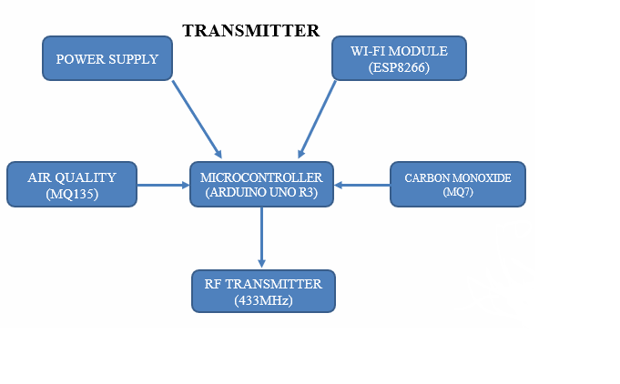**3.2 TRANSMITTER SIDE BLOCK DIAGRAM**

**Fig. 3.1 Transmitter side Block diagram**

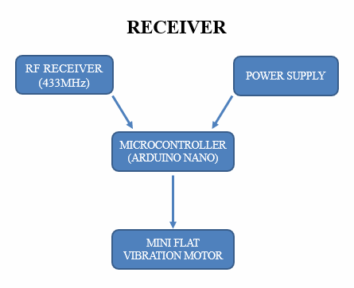**3.3 RECEIVER SIDE BLOCK DIAGRAM**

**Fig. 3.2 Receiver side Block diagram**

**3.4 ARDUINO UNO R3**

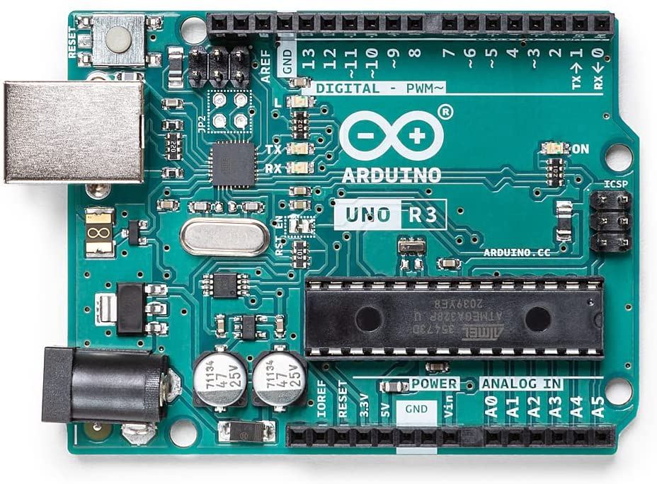

**Fig. 3.3 Arduino UNO**

Fig 3.3 shows the Arduino UNO R3. It is an MCU with Atmega328p chip. It has 14 digital I/O pins, 6 Analog inputs, 16 MHz quartz crystal oscillator for certain frequency generation, a USB connection port, a power jack, an ICSP header and a reset button. This board contains necessary electronic components onboard needed to support the MCU; just need to connect it to a computer with a USB cable or an AC-to-DC adapter or battery to power it up.

The newly developed Arduino UNO board is adapted from the Arduino Uno R1. The Arduino languages are C, C++. It is used for real time application. The Arduino has an expansive help network and a board arrangement of help libraries and equipment add-on making it an extraordinary platform for embedded systems.

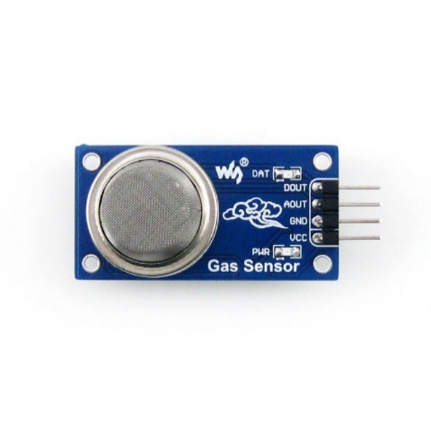**3.5 MQ7 GAS SENSOR**

**Fig. 3.4 MQ7 Gas sensor**

This sensor contains a sensing element, which is aluminium-oxide based ceramic, coated with Tin dioxide (SiO2). Whenever CO gas come into contact with the sensing element, to get the concentration of the gases present in the air.

It can detect the CO gas in the range of 20-2000ppm in air. Its operating voltage is +5v, Analog output voltage is 0-5v, it has VCC, GND, Analog and Digital pins. It is stable, long life and low cost. It has fast response time. To power it, connect the VCC pin to 5v pin of Arduino and GND to the GND pin of MCU, connect the Analog pin to the A1 of Arduino.

**Table 3.1 Specifications of MQ7**

|  |  |  |  |
| --- | --- | --- | --- |
| **Symbol** | **Parameter name** | **Technical condition** | **Remark** |
| Vc | circuit voltage | 5V±0.1 | Ac or Dc |
| VH (H) | Heating voltage (high) | 5V±0.1 | Ac or Dc |
| VH (L) | Heating voltage (low) | 1.4V±0.1 | Ac or Dc |
| RL | Load resistance | Can adjust |  |
| RH | Heating resistance | 33Ω±5% | Room temperature |
| TH (H) | Heating time (high) | 60±1 seconds |  |
| TH (L) | Heating time (low) | 90±1 seconds |  |
| PH | Heating consumption | About 350mW |  |

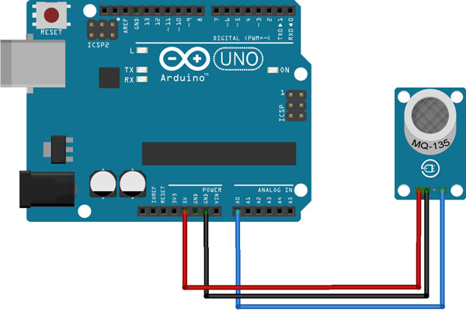**3.6 MQ135 GAS SENSOR**

**Fig. 3.5 MQ135 Gas sensor**

It is used to detect Carbon-di-oxide, H2S in the air. This sensor has 4 pins which are VCC, GND, Analog and Digital pins. When the level of the above gases in the environment is go beyond the threshold value, Analog pin read the instant values and print it in the serial monitoring window. This sensor operates between 2.5V to 5V and consumes power around 150mA. It’s VCC and GND pins are to connect with VCC and GND pins of Arduino. Analog pin of MQ135 to A0 and take output at 13th pin of Arduino.

**Table 3.2 Specifications of MQ135**

|  |  |  |  |
| --- | --- | --- | --- |
| Symbol | Parameter name | Technical condition | Remarks |
| Vc | Circuit voltage | 5V±0.1 | AC OR DC |
| VH | Heating voltage | 5V±0.1 | ACOR DC |
| RL | Load resistance | can adjust |  |
| RH | Heater resistance | 33Ω±5% | Room Tem |
| PH | Heating consumption | less than 800mw |  |

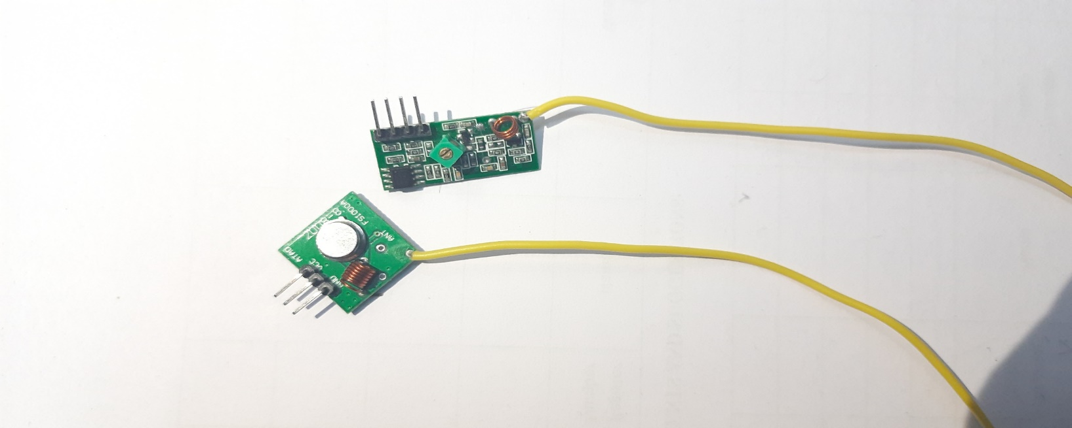**3.7 RF MODULE: (TRANSMITTER AND RECEIVER)**

**Fig. 3.6 RF module**

In many projects, usually RF module is used to transmit and receive the data because it has high volume of applications than IR. This RF module is a combination of RF transmitter and Receiver. This pair operates at a Range of 433MHz. The operating voltage of transmitter is between 3v to 6v and receiver is 5v. Main advantage of this is Low power consumption. Receiver supply current is 3.5mA. Transmitter has 3 pins which are Data, ground, and VCC as well as Receiver has 4 pins which are VCC, GND, and 2 digital data pins (2 are internally connected). RF transmitter (Radio Frequency) receives serial data and transmits it wirelessly through its Rf Antenna. The transmission occurs at the rate of 1kbps-10kbps. It offers only one way communication through 433.92MHz. It transmits up to 3 metres, if an antenna is added to it, its capable up to 100 metres. The module uses the ASK modulation method to transmit the data. The data pin of both transmitter and receiver are connected to the 12th of both Arduinos. At the receiver, it delivers the output to the data pin in an encoded form. Output of Receiver is got from the 7th pin. Some of the applications of RF module are Vehicle monitoring, Remote control, Telemetry, Wireless fire protection, etc.

**3.8 MINI FLAT VIBRATION MOTOR**

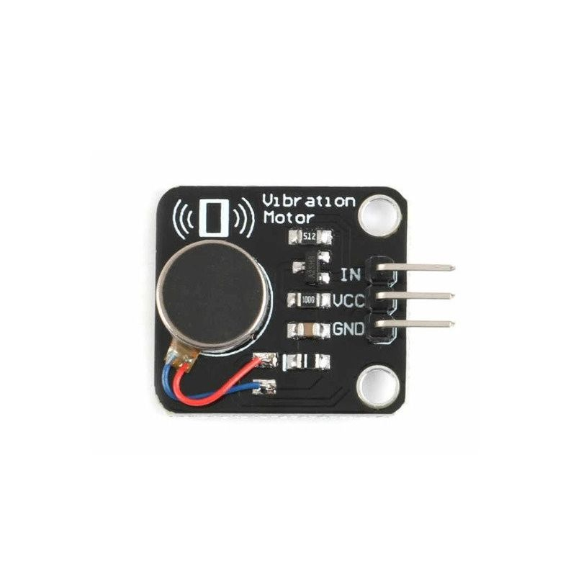

**Fig. 3.7 Mini flat Vibration motor**

It is an Output component and used as to alert the worker when toxic is detected. Its operating voltage is between 3v to 5v, power consumption is up to 60mA. It has a high-rate speed of about 9000 RPM, this motor size is very small so comfortable for worker to wear in hand. It has 3 pins which are GND, VCC, and input pin. The input pin is connected to the out of Rf receiver which is 7th pin.

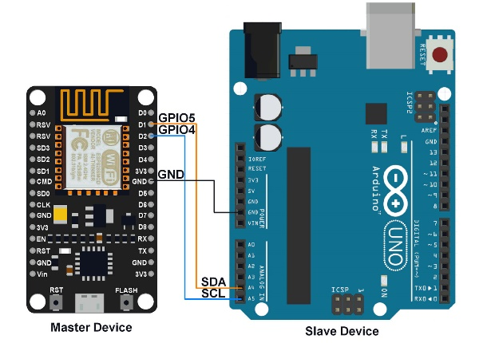

**3.9 ESP8266 NODE MCU**

**Fig. 3.8 ESP8266 Node MCU**

ESP8266 Node MCU is a low-cost open source IOT platform. It initially included firmware which runs on the ESP8266 Wi-Fi SOC from Espressif systems, and hardware which was based on the ESP-12 module. Later, support for the ESP32 32-bit MCU was added. Frequency range is 2.4GHz. It can be powered through the USB port as well as Vin pin, its operating voltage is 3.0 to 3.6V. It has a reset pin, A0 pin used to measure Analog output, And Node MCU has 16 general purpose input-output pins, 4 pins available for SPI communication, 2 UART interfaces UART0 (RXD0 & TXD0) and UART1 (RXD1 & TXD1) on its board. Its Flash memory is 4MB, SRAM is 64KB, clock speed is 80MHz. Small sized module to fit smartly inside this system model.

**3.10 ARDUINO IDE**

Arduino software makes it easy to write code and upload it to the board. For Arduino UNO, The Arduino UNO board manager is to be selected and it comes preprogramed with a bootloader that asks for a new code to it without using an outside equipment developer. Before uploading the sketch, selection of correct board and ports are to be done. The latest Arduino boards can be reset automatically before beginning with upload. The serial monitor button is present on the right corner of the toolbar. The terminal program should be connected to the COM port, which will be assigned when the board is connected to the computer.

**3.11 ARDUINO PROGRAMMING**

The Huge 2560 board can be configured with the Arduino Software application (IDE). The ATmega2560 on the Huge 2560 comes preprogramed with a boot loader that asks for a new code to it without using an outside equipment developer. It interacts utilizing the initial STK500 procedure (recommendation, C header data). bypassing the boot loader and program the micro controller with the ICSP (In-Circuit Serial Programs) header utilizing Arduino ISP also can be done**.**

**3.12 IFTTT (IF THIS THEN THAT)**

**Fig. 3.9 IFTTT interface in system to connect with ESP8266**

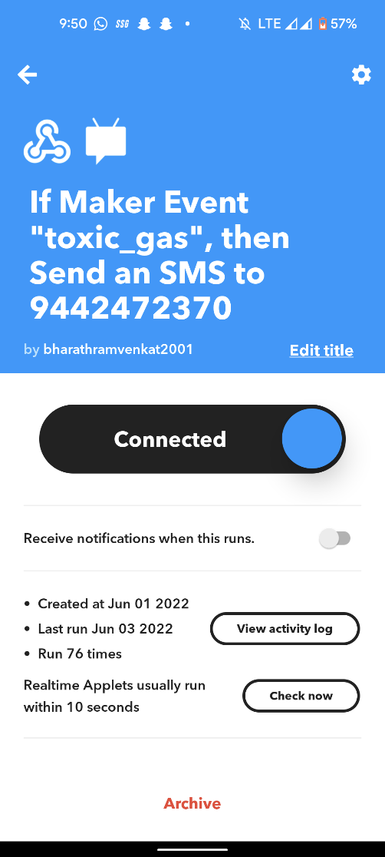

**Fig. 3.10 IFTTT interface in mobile to connect with ESP8266**

IFTTT stands for “If This Then That.” Basically, if certain conditions are met, then something else will happen. The “if this” part is called a trigger, and the “then that” part is called an action.

This android application should be installed in the receiver’s mobile phone. In that application, change the required things such as enter the receiver mobile number, create event name, and type the message that is needed to be sent. After all stuffs are done, generation of link is to be done and copy the link in the ESP8266 code.

IFTTT is so easy to use that anyone can learn it in minutes. Only one account is required. From there, just a few clicks and process is done. Install the IFTTT app on any Android or iPhone, or use the IFTTT website. Connect to any Apple, Facebook, or Google account to sign in, or sign in with personal email address. From the home screen or website dashboard, select Explorer to search for the applet. User can enter what they are looking for in the search bar or browse for a list of popular IFTTT applets. Select an applet. Grant permissions for the app or service that the applet is accessing. Follow the instructions on the screen.

A link like this will be generated in the IFTTT application, “/trigger/toxic_gas/json/with/key/fGbn4jDEOUXeSJ6cbcyaEe8LRstwFx7Zqq2wdUjmr6F”

The link should be pasted in the Arduino transmitter code which is connecting both the Arduino and ESP8266.

**CHAPTER 4**

**IMPLEMENTATION**

**4.1 INTRODUCTION**

In this section, the architecture of the proposed Toxic gas detection and alert system is discussed. At present as the use of gases in industries increases, the number of accidents that occur as a result was also increases. These accidents occurred from gas pipelines and gas cylinders. The result is casualty that can even take valuable lives. Therefore, proper monitoring and maintenance is a must to avoid this kind of pathetic accident. That is why technical detection and alerting system is implemented. The goal of the work is to develop the hardware and software of the information-measuring system based on the inexpensive Arduino platform which detects toxic gases in the air, and when exceeding their maximum permissible concentration, intimate vibration, and the output of the warning message.

**4.2 ARDUINO CONFIGURATIONS**

**Table 4.1 Arduino configuration**

|  |  |  |
| --- | --- | --- |
| **PIN CATEGORY** | **PIN NAME** | **DETAILS** |
| Power | Vin, 3.3V, 5V, GND | Vin: Input voltage to Arduino when using an external power source.  5V: Regulated power supply used to power microcontroller and other components on the board.  3.3V: 3.3V supply generated by on-board voltage regulator. Maximum current draw is 50mA.  GND: ground pins. |
| Reset | Reset | Resets the microcontroller. |
| Analog Pins | A0 – A5 | Used to provide analog input in the range of 0-5V |
| Input/Output Pins | Digital Pins 0 - 13 | Can be used as input or output pins. |
| Serial | 0(Rx), 1(Tx) | Used to receive and transmit TTL serial data. |
| External Interrupts | 2, 3 | To trigger an interrupt. |
| PWM | 3, 5, 6, 9, 11 | Provides 8-bit PWM output. |
| SPI | 10 (SS), 11 (MOSI), 12 (MISO) and 13 (SCK) | Used for SPI communication. |
| Inbuilt LED | 13 | To turn on the inbuilt LED. |
| TWI | A4 (SDA), A5 (SCA) | Used for TWI communication. |
| AREF | AREF | To provide reference voltage for input voltage. |

**4.3 TRANSMITTER SIDE CONNECTION**

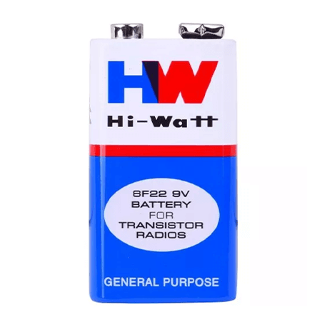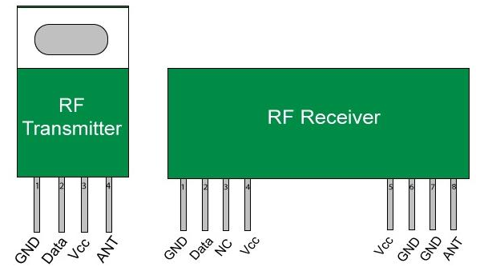







**Fig. 4.1 Transmitter connection**

**4.4 RECEIVER SIDE CONNECTION**



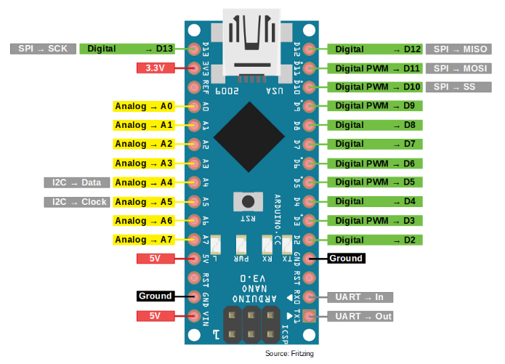

**Fig. 4.2 Receiver connection**

**4.5 ARCHITECTURE**

A 6V-20V power supply is required to power the board. In any case, if the power supply is less than 7 V, a 5-volt stick will supply less than 5 volts and the board may wobble. Using a voltage above 12V can overheat the voltage regulator and damage the board. The specified range is 7 to 12 volts. Basically, positive side of the battery is need to be connected to the Arduino VIN and the terminal to the Arduino Ground. The Arduino's green light should be on to indicate that user is in control. It's also a wise idea to connect a toggle switch in combination with its battery. That way, user can kill Arduino and beyond. Arduino is controlled via a USB connection from the PC. Still, self-managed, battery-controlled frames need to be assembled here and there. A battery is required to control the Arduino. The best way is to have special control over the Arduino from the battery. This eliminates the need to use a voltage regulator that consumes power.

The functionality of system is divided into three main steps. In the initial step, the gas leakage is detected by the gas sensor. This detects the gas leakage and gives the signal to the microcontroller. After that in second step the microcontroller receives the signal, which sends by gas sensor. Arduino act as a microcontroller and in the final step the system works in two cases.

For transmitter, connect the MQ7, MQ135, RF transmitter, ESP8266 to the MCU. For receiver, connect RF receiver, Mini flat vibration motor to MCU. Common connections are VCC and GND. All the pins of VCC and GND of all components are connected common. Then, Analog pin of MQ135 and MQ7 are connected to the A0 and A1 of Arduino, data pin of Rf transmitter is connected to 12th pin, D2 and D3 pins of ESP8266 are connected to the 3rd and 4th pins of MCU. In receiver, 2nd pin of Arduino is connected to the Vibration motor. When the sensor is starting sense, the collected data are given to the Arduino analog inputs. The Arduino converts the analog values into digital values. The board functions are controlled by the set of instructions through the Arduino IDE software. If it goes above the fixed ppm in air, the information was transferred wirelessly through Rf transmitter and received by the Rf receiver, while it receives the vibration motor starts vibrate and alert the worker to go away from the hazardous area, this is 1st case, 2nd case is when sensor start sensing, the sensor output is given to the ESP8266 and with the help of IFTTT android application send the warning message to the authority person, for to send the rescue team to the spot.

**4.6 INTERFACING ESP8266 WITH ARDUINO**

This is the Embedded wireless technology that is web friendly with no use of shields or any peripherals, as is required for Arduino. The price and size are the USP of the module with the added advantage of good speed and processing power. L106 32-bit RISC microprocessor core based on the Tensilica Diamond Standard 106Micro running at 80 MHz

Memory Classification

• 32 KB instruction RAM

• 32 KB instruction cache RAM

• 80 KB user-data RAM

• 16 KB ETS system-data RAM

It has 17 GPIO pins and Pin configuration as shown below,

1. GND, Ground (0 V)

2. GPIO 2, General-purpose input/output No. 2

3. GPIO 0, General-purpose input/output No. 0

4. RX, Receive data in, also GPIO3

5. VCC, Voltage (+3.3 V; can handle up to 3.6 V)

6. RST, Reset

7. CH_PD, Chip power-down

8. TX, Transmit data out, also GPIO 1

**4.7 TRANSMITTER CODE**

**Table 4.2 Transmitter code**

|  |  |
| --- | --- |
| **CODE** | **DESCRIPTION** |
| #include <RH_ASK.h> | Include RadioHead Amplitude Shift Keying Library |
| #include <SoftwareSerial.h> | Allows serial communication in all pins |
| SoftwareSerial ArduinoUno(2,3); | Declare the Pins |
| #include <SPI.h> | Include dependant SPI Library |
| int sensorvalue; | Variable for storing measured values of MQ135 |
| int sensorvalue2; | Variable for storing measured values of MQ7 |
| RH_ASK rf_driver; | Create Amplitude Shift Keying Object |
| void setup () { |  |
| rf_driver.init(); | Initialize ASK Object |
| Serial.begin(9600); | Serial communication, so that the Arduino can send out commands |
| ArduinoUno.begin(4800);  } | Arduino messages interchanged with serial monitor |
| void loop ()  { |  |
| sensorvalue = analogRead(0); | MQ135 sensor read anlaog values and store in sensorvalue variable |
| sensorvalue2 = analogRead(1); | MQ7 sensor read anlaog values and store in sensorvalue2 variable |
| Serial.println(sensorvalue,DEC); | Sensed value print in Serial monitor window |
| If (sensorvalue > 200)  { | Check the condition |
| const char *msg = "MQ135"; | Declare the character to be transmit |
| rf_driver.send((uint8_t*)msg,strlen(msg)); | Send function to send the character wirelessly |
| rf_driver.waitPacketSent(); | Wait until entire character to be send |
| ArduinoUno.print(sensorvalue); | Print the sensor values in serial monitor window |
| ArduinoUno.println("\n");  } | Print new line |
| else if (sensorvalue2 > 100)  { |  |
| const char *msg = "MQ7”; | Declare the character to be transmit |
| rf_driver.send((uint8_t *)msg, strlen(msg)); | Send function to send the character wirelessly |
| rf_driver.waitPacketSent(); | Wait until entire character to be send |
| ArduinoUno.print(sensorvalue);  } | Print the sensor values in serial monitor window |
| Delay (1000);  } |  |

**4.8 RECEIVER CODE:**

**Table 4.3 Receiver code**

|  |  |
| --- | --- |
| **CODE** | **DESCRIPTION** |
| #include<RH_ASK.h> | Include RadioHead Amplitude Shift Keying Library |
| #include<SPI.h> | Include dependant SPI Library |
| RH_ASK rf_driver; | Create Amplitude Shift Keying Object |
| void setup ()  { |  |
| rf_driver.init(); | Initialize ASK Object |
| Serial.begin(9600);  } | Serial communication, so that the Arduino can send out commands |
| void loop()  { | Serial communication, so that the Arduino can send out commands |
| uint8_t buf[5]; | Initialize the size of message |
| uint8_t buflen = sizeof(buf); |  |
| if (rf_driver.recv(buf, &buflen))  { | Non-blocking |
| digitalWrite(3, HIGH); | Mini flat vibration motor’s LED glows |
| digitalWrite(4, HIGH); | Mini flat vibration motor starts vibrate |
| Serial.print("Message Received: "); | Message received |
| Serial.println((char*)buf);  } | Gas detection message from MQ135 or MQ7 |
| else  { |  |
| digitalWrire(3, LOW); |  |
| digitalWrire(4, LOW); |  |
| delay(1000);  } |  |

**4.9 FLOW CHART**

Establish connection between Sensors, Rf & Wi-Fi module with Arduino

Arduino board functions controlled by set of instructions via Arduino IDE

MQ7 & MQ135 sensors measure Toxic gas level in atmosphere

Sensor > Threshold value value

**NO**

**YES**

1.Character transmit through Rf module

2. Warning message transmit via Wi-Fi

1. Vibration motor Alert the worker

2. Authority send rescue team to hazardous area

**Fig. 4.3 Flow diagram defining the working of proposed model**

# CHAPTER 5

# RESULTS

* 1. **INTRODUCTION**

This chapter presents the complete hardware setup, with the transmitter and receiver side connection, the results of the sensor values in Serial monitor window, working of the Rf transmitter and receiver and working of Mini flat vibration motor.

# COMPLETE HARDWARE SETUP

# 

**Fig. 5.1 Implementation of proposed model**

Fig 5.2 shows the complete setup of the project. The setup has 2 Arduino boards to the PC through Arduino cable. Connect the MQ7 and MQ135 sensors, ESP8266 node MCU and RF transmitter as well as the RF receiver, Mini flat vibration motor to the receiving Arduino.

# SENSOR VALUES

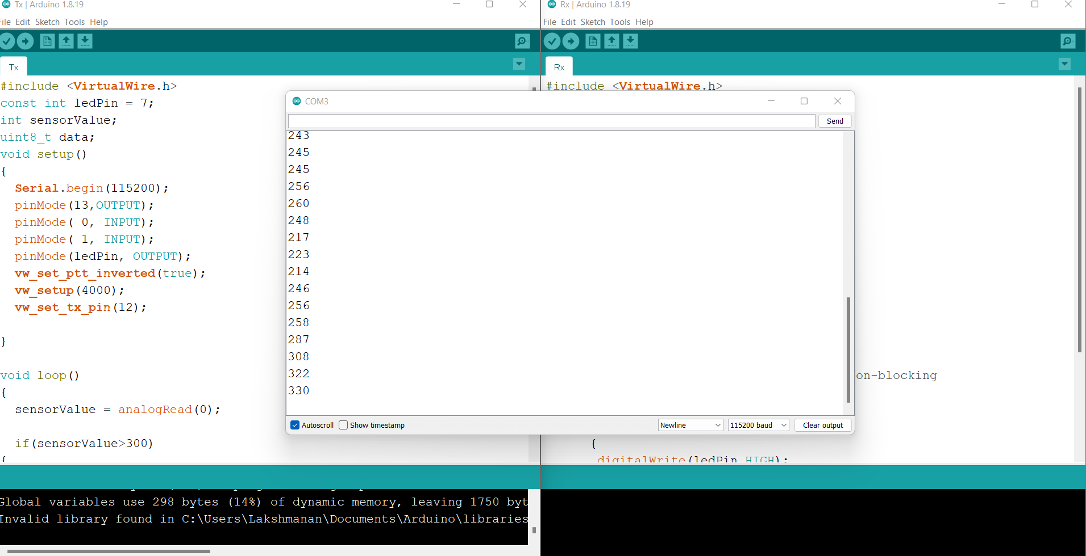

**Fig. 5.2 MQ7 and MQ135 Sensor values depicting CO2**

Fig 5.3 shows the real sensor values and print that in the serial monitoring window. By use of MQ7 and MQ135 sensors calculate the real time values. It may vary according to the atmosphere. Less than 1000ppm of CO2 level in air is the inhale capable of Human. If the level goes above 1000ppm it may cause dangerous effect to humans. Hence, the MQ135 sensor range is useful for the workers who are working in the Industrial environment. As well as MQ7, Normal level in air is 0 to 500ppm, if the value goes above, it will affect human. Then give the sensed values to the Arduino in the A0 pin. Arduino read the analog values and print it in the serial monitoring window.

# WORKING OF MINI FLAT VIBRATION MOTOR

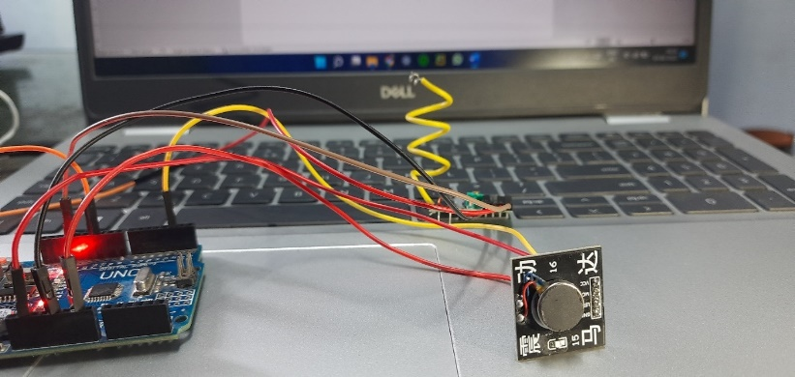

**Fig. 5.3 Working of mini flat vibration motor**

For mini flat vibration motor a unique code is needed in the Arduino IDE. After the sensing of gas sensor, the character transferred from transmitter to receiver. Then the vibration motor connected at the receiver part start vibrate. From the vibration worker intimate to move away from that area.

**5.5 OBSERVED OUTPUT**

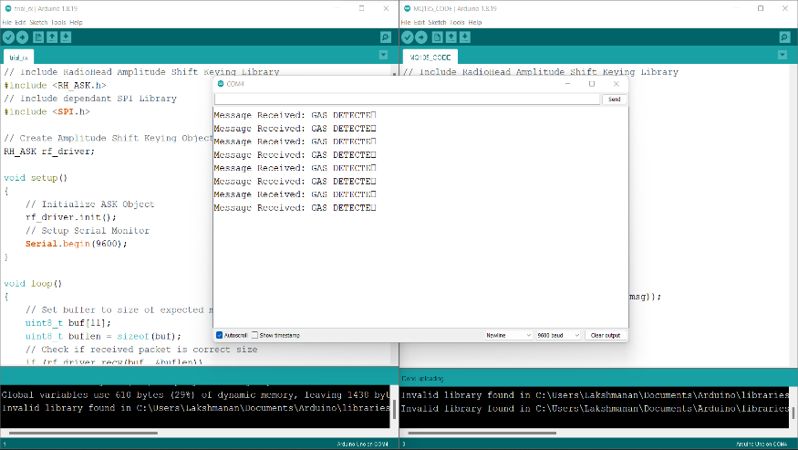

**Fig. 5.4 Receiver output for gas detection**

Fig 5.4 shows the displayed output. After the character is received by the RF transmitter, the DC vibration motor which is connected to Arduino start vibrate and alert the worker as well as the print the message in the serial monitoring window. This shows the character is received correctly.

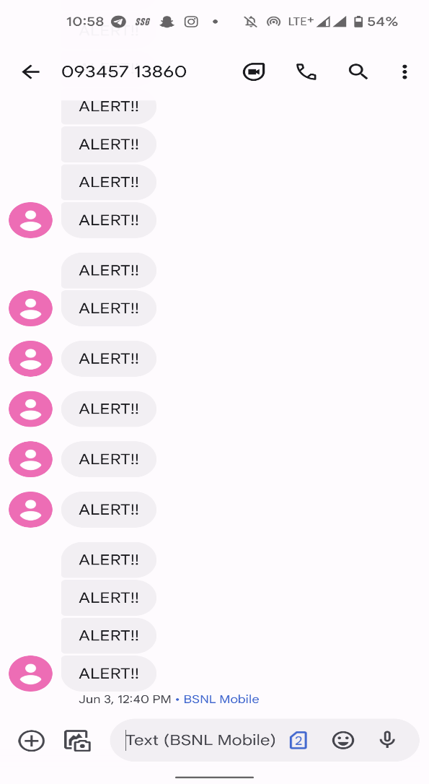

**Fig. 5.5 Alert message received at mobile app**

# 5.6 SUMMARY

Thus, the worker is alerted by the help of mini flat vibration motor and the Manager is alerted by the means of SMS through ESP 8266 and the toxic gas levels are recorded in Serial monitor and can be viewed by the manager at any time.

# CHAPTER 6

# CONCLUSION

Safety is the best measure to prevent accidents. There are many accidents occurred due to leakage of gases around the world. Technology can also play a major role in saving a life from this toxic environment. This Proposed system model overcomes those incidents. This is a low-cost, low power, lightweight, portable, safe, user friendly, efficient, multi featured and simple system device for detecting gas. The adjustment in, carbon monoxide, Carbon-di-oxide will be recognized by separate sensors and can be resolved. Fig. 5.5 shows the SMS notified when harmful gases levels have been raised from normal level to harmful level. And also, authority sends rescue team to that area.

Fig. 5.1 shows the transmission of character from Rf transmitter to receiver after toxic was detected and vibration motor vibrates for to intimate the worker to go away. With the help of this system, the critical situations can be solved quickly over the manual methods, which require large amount of time.

# REFERENCES

[1]. Alice Mary K, Perreddy Monica, Apsurrunisa A, Chatala Sreekanth and Pavan G, “IoT based garbage monitoring system”, International Journal of Scientific and Engineering Research, Vol-8, pp.81-90, 2017.

[2]. Antolin D, Medrano N, Calvo B, and Perez F, “A wearable wireless sensor network for indoor smart environment monitoring in safety applications”, International Journal of Scientific and Engineering Research, Vol-17, pp.365, 2017.

[3]. Bichinapally Sruthi, “Alerting and detection of toxic gases in industries using the internet of things”, International Journal of Pure and Applied Mathematics, Vol-120, pp.5, 2018.

[4]. Chalasani Srinivas and Mohan Kumar, “Toxic gas detection and monitoring utilizing IoT”, International Journal of Civil Engineering and Technology,Vol-8, pp.641-622, 2018.

[5]. Holovatyy A, Teslyuk V, Lobur, Pobereyko M and Sokolovsky Y, “Development of arduino-based embedded system for detection of toxic gases in air”, International Scientific and Technical Conference on Computer Sciences and Information Technologies, Vol-6, pp.139-142, 2018.

[6]. Jain and Rajesh Kushwaha, “Wireless gas sensor network for detection and monitoring of harmful gases in utility areas and industries”, International Conference on Sensing Technology, Vol-12, pp.220, 2018.

[7]. Jianyun Ni, Zohao Li, Shuzhixie and Chao jia, “Detection of hazardous gas using wearable wireless sensor networks for industrial applications”, Chinese Control Conference, Vol-13, pp.78, 2019.

[8]. Kim D and Kim S, “A portable colorimetric array reader for toxic gas detection” International Symposium on Olfaction and Electronic Nose (ISOEN), Vol-94, pp.1-3, 2017.

[9]. Karthika S, Vanitha U, Rejina Parvin J, SuprajaArasu T, Sampritha R V and Srinithi K, “Toxic gas detection using Low power controller with Alert system”, International Journal of Innovative Technology and Exploring Engineering, Vol-8, pp.10, 2019.

[10]. Katole K R, Tamgade S N and Morey P R, “Design and Implementation of Hazardous gas leakage detection system for industrial area”, International Journal of Engineering Research and Technology, Volume 7, pp.2, 2019.

[11]. Mobasshir Mahbub, “Toxic and hazardous gas detection, measurement and monitoring system for safety assurance in home and industrial application of wireless sensor node”, Engineering and Technology Research, Vol-5, pp.89-98, 2019.

[12]. Mohammad Monirujjaman Khan, “Sensor-based gas leakage detector system”, Electronic Conference on Sensors and Applications, Vol-2, pp.15-30, 2020.